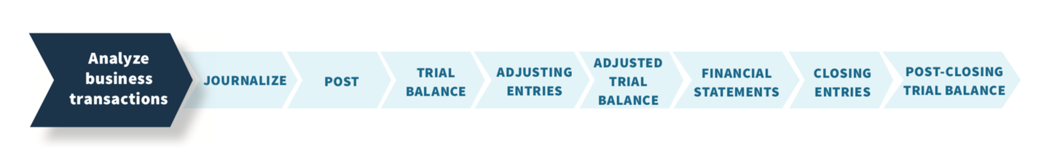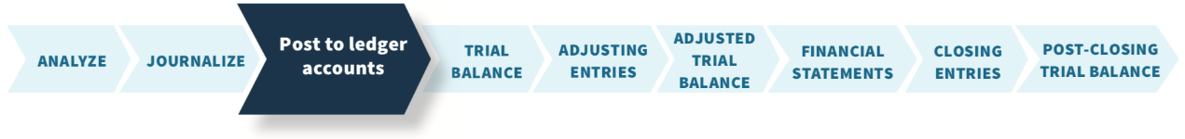

An illustration of nine transactions presented in the general journal format. This illustration presents a label at the top with the label, General Journal, centered and the label Page J 1 appears on the top right corner. The next line presents five column headings of the journal as Date, Account Titles and Explanation, Reference, Debit, and Credit. Immediately under the Date column label, 2025 is displayed followed by October 1. The debit part of the first transaction is recorded by presenting the account name, Cash, adjacent to the date in the next column and its amount of 10,000 in the debit column with a reference number of 101. The second part of the transaction is illustrated by presenting the credit account name, Share Capital-Ordinary, slightly indented on the next line with its 10,000 amount in the credit column with a reference number of 311. Just below the Share Capital-Ordinary account name and slightly indented appears the description of the journal entry as: Issued shares for cash.The date of the second transaction is displayed as October 1. The debit part of the transaction is recorded by presenting the account name, Equipment, adjacent to the date in the next column and its amount of 5,000 in the debit column with a reference number of 157. The second part of the transaction is illustrated by presenting the credit account name, Notes Payable, slightly indented on the next line with its 5,000 amount in the credit column with a reference number of 200. Just below the Notes Payable account name and slightly indented appears the description of the journal entry as: Issued 3-month, 12% note for office equipment.The date of the third transaction is displayed as October 2. The debit part of the transaction is recorded by presenting the account name, Cash, adjacent to the date in the next column and its amount of 1,200 in the debit column with a reference number of 101. The second part of the transaction is illustrated by presenting the credit account name, Unearned Service Revenue, slightly indented on the next line with its 1,200 amount in the credit column with a reference number of 209. Just below the Unearned Service Revenue account name and slightly indented appears the description of the journal entry as: Received cash from R. Knox for future services.The date of the fourth transaction is displayed as October 3. The debit part of the transaction is recorded by presenting the account name, Rent Expense, adjacent to the date in the next column and its amount of 900 in the debit column with a reference number of 729. The second part of the transaction is illustrated by presenting the credit account name, Cash, slightly indented on the next line with its 900 amount in the credit column with a reference number of 101. Just below the Cash account name and slightly indented appears the description of the journal entry as: Paid October rent.The date of the fifth transaction is displayed as October 4. The debit part of the transaction is recorded by presenting the account name, Prepaid Insurance, adjacent to the date in the next column and its amount of 600 in the debit column with a reference number of 130. The second part of the transaction is illustrated by presenting the credit account name, Cash, slightly indented on the next line with its 600 amount in the credit column with a reference number of 101. Just below the Cash account name and slightly indented appears the description of the journal entry as: Paid one-year policy; effective date October 1.The date of the sixth transaction is displayed as October 5. The debit part of the transaction is recorded by presenting the account name, Supplies, adjacent to the date in the next column and its amount of 2,500 in the debit column with a reference number of 126. The second part of the transaction is illustrated by presenting the credit account name, Accounts Payable, slightly indented on the next line with its 2,500 amount in the credit column with a reference number of 201. Just below the Accounts Payable account name and slightly indented appears the description of the journal entry as: Purchased supplies on account from Aero Supply.The date of the seventh transaction is displayed as October 20. The debit part of the transaction is recorded by presenting the account name, Dividends, adjacent to the date in the next column and its amount of 500 in the debit column with a reference number of 332. The second part of the transaction is illustrated by presenting the credit account name, Cash, slightly indented on the next line with its 500 amount in the credit column with a reference number of 101. Just below the Cash account name and slightly indented appears the description of the journal entry as: Declared and paid a cash dividend.The date of the eight transaction is displayed as October 26. The debit part of the transaction is recorded by presenting the account name, Salaries and Wages Expense, adjacent to the date in the next column and its amount of 4,000 in the debit column with a reference number of 726. The second part of the transaction is illustrated by presenting the credit account name, Cash, slightly indented on the next line with its 4,000 amount in the credit column with a reference number of 101. Just below the Cash account name and slightly indented appears the description of the journal entry as: Paid salaries to date.The date of the ninth transaction is displayed as October 31. The debit part of the transaction is recorded by presenting the account name, Cash, adjacent to the date in the next column and its amount of 10,000 in the debit column with a reference number of 101. The second part of the transaction is illustrated by presenting the debit account name, Service Revenue, on the next line with its 10,000 amount in the debit column with a reference number of 400. Just below the Service Revenue account name and slightly indented appears the description of the journal entry as: Received cash for services performed.An illustration presents a summary of twelve general ledgers. General ledger 1: Illustration of the general journal format is presented. This illustration presents a label at the top with the label, Cash, centered. The next line presents six column headings of the journal as Date, Explanation, Reference, Debit, Credit, and Balance. Immediately under the Date column label, 2025 is presented. The first transaction dated, October 1, with reference number J 1, is recorded in an amount of 10,000 in the debit column and 10,000 in the balance column. The second transaction dated, October 2, with reference number J 1, is recorded in an amount of 1,200 in the debit column and 11,200 in the balance column. The third transaction dated, October 3, with reference number J 1, is recorded in an amount of 900 in the credit column and 10,300 in the balance column. The fourth transaction dated, October 4, with reference number J 1, is recorded in an amount of 600 in the credit column and 9,700 in the balance column. The fifth transaction dated, October 20, with reference number J 1, is recorded in an amount of 500 in the credit column and 9,200 in the balance column. The sixth transaction dated, October 26, with reference number J 1, is recorded in an amount of 4,000 in the credit column and 5,200 in the balance column. The seventh transaction dated, October 31, with reference number J 1, is recorded in an amount of 10,000 in the debit column and 15,200 (highlighted) in the balance column. ‘The journal page number '101' appears in the upper right corner.’ General ledger 2: Illustration of the general journal format is presented. This illustration presents a label at the top with the label, Supplies, centered. The next line presents six column headings of the journal as Date, Explanation, Reference, Debit, Credit, and Balance. Immediately under the Date column label, 2025 is presented. One transaction dated, October 5, with reference number J 1, is recorded in an amount of 2,500 in the debit column and 2,500 (highlighted) in the balance column. ‘The journal page number '126' appears in the upper right corner.’ General ledger 3: Illustration of the general journal format is presented. This illustration presents a label at the top with the label, Prepaid Insurance, centered. The next line presents six column headings of the journal as Date, Explanation, Reference, Debit, Credit, and Balance. Immediately under the Date column label, 2025 is presented. One transaction dated, October 4, with reference number J 1, is recorded in an amount of 600 in the debit column and 600 (highlighted) in the balance column. ‘The journal page number '130' appears in the upper right corner.’ General ledger 4: Illustration of the general journal format is presented. This illustration presents a label at the top with the label, Equipment, centered. The next line presents six column headings of the journal as Date, Explanation, Reference, Debit, Credit, and Balance. Immediately under the Date column label, 2025 is presented. One transaction dated, October 1, with reference number J 1, is recorded in an amount of 5,000 in the debit column and 5,000 (highlighted) in the balance column. ‘The journal page number '157' appears in the upper right corner.’ General ledger 5: Illustration of the general journal format is presented. This illustration presents a label at the top with the label, Notes Payable, centered. The next line presents six column headings of the journal as Date, Explanation, Reference, Debit, Credit, and Balance. Immediately under the Date column label, 2025 is presented. One transaction dated, October 1, with reference number J 1, is recorded in an amount of 5,000 in the credit column and 5,000 (highlighted) in the balance column. ‘The journal page number '200' appears in the upper right corner.’ General ledger 6: Illustration of the general journal format is presented. This illustration presents a label at the top with the label, Accounts Payable, centered. The next line presents six column headings of the journal as Date, Explanation, Reference, Debit, Credit, and Balance. Immediately under the Date column label, 2025 is presented. One transaction dated, October 5, with reference number J 1, is recorded in an amount of 2,500 in the credit column and 2,500 (highlighted) in the balance column. ‘The journal page number '201' appears in the upper right corner.’ General ledger 7: Illustration of the general journal format is presented. This illustration presents a label at the top with the label, Unearned Service Revenue, centered. The next line presents six column headings of the journal as Date, Explanation, Reference, Debit, Credit, and Balance. Immediately under the Date column label, 2025 is presented. One transaction dated, October 2, with reference number J 1, is recorded in an amount of 1,200 in the credit column and 1,200 (highlighted) in the balance column. ‘The journal page number '209' appears in the upper right corner.’ General ledger 8: Illustration of the general journal format is presented. This illustration presents a label at the top with the label, Share Capital-Ordinary, centered. The next line presents six column headings of the journal as Date, Explanation, Reference, Debit, Credit, and Balance. Immediately under the Date column label, 2025 is presented. One transaction dated, October 1, with reference number J 1, is recorded in an amount of 10,000 in the credit column and 10,000 (highlighted) in the balance column. ‘The journal page number '311' appears in the upper right corner.’ General ledger 9: Illustration of the general journal format is presented. This illustration presents a label at the top with the label, Dividends, centered. The next line presents six column headings of the journal as Date, Explanation, Reference, Debit, Credit, and Balance. Immediately under the Date column label, 2025 is presented. One transaction dated, October 20, with reference number J 1, is recorded in an amount of 500 in the debit column and 500 (highlighted) in the balance column. ‘The journal page number '332' appears in the upper right corner.’ General ledger 10: Illustration of the general journal format is presented. This illustration presents a label at the top with the label, Service Revenue, centered. The next line presents six column headings of the journal as Date, Explanation, Reference, Debit, Credit, and Balance. Immediately under the Date column label, 2025 is presented. One transaction dated, October 31, with reference number J 1, is recorded in an amount of 10,000 in the credit column and 10,000 (highlighted) in the balance column. ‘The journal page number '400' appears in the upper right corner.’ General ledger 11: Illustration of the general journal format is presented. This illustration presents a label at the top with the label, Salaries and Wages Expense, centered. The next line presents six column headings of the journal as Date, Explanation, Reference, Debit, Credit, and Balance. Immediately under the Date column label, 2025 is presented. One transaction dated, October 26, with reference number J 1, is recorded in an amount of 4,000 in the debit column and 4,000 (highlighted) in the balance column. ‘The journal page number '726' appears in the upper right corner.’ General ledger 12: Illustration of the general journal format is presented. This illustration presents a label at the top with the label, Rent Expense, centered. The next line presents six column headings of the journal as Date, Explanation, Reference, Debit, Credit, and Balance. Immediately under the Date column label, 2025 is presented. One transaction dated, October 3, with reference number J 1, is recorded in an amount of 900 in the debit column and 900 (highlighted) in the balance column. ‘The journal page number '729' appears in the upper right corner.’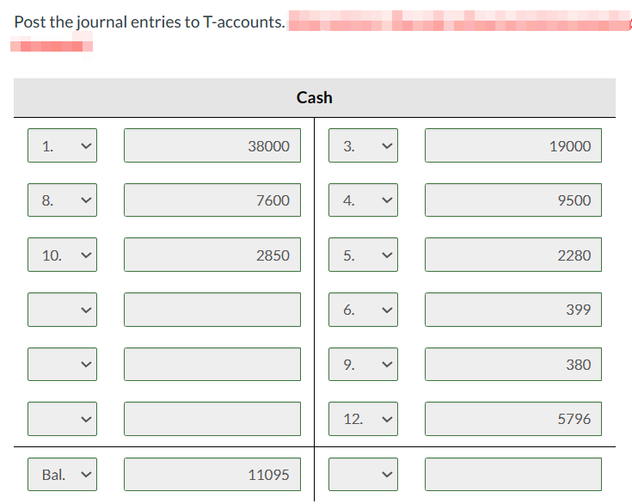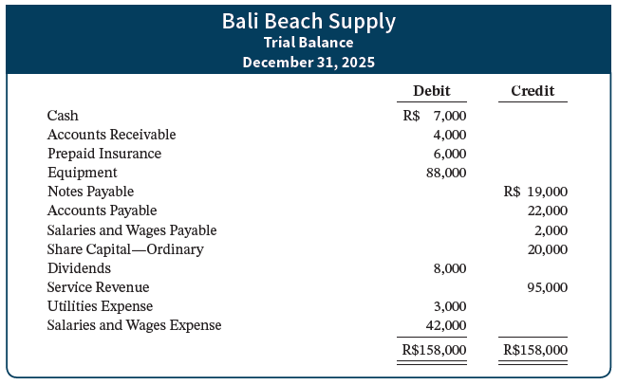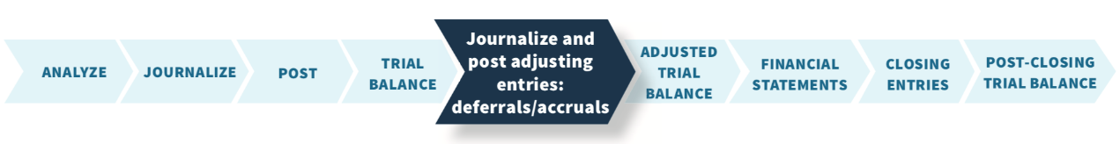An illustration of seven transactions presented in the general journal format. This illustration presents a label at the top with the label, General Journal, centered and the label Page J 2 appears on the top right corner. The next line presents five column headings of the journal as Date, Account Titles and Explanation, Reference, Debit, and Credit. Immediately under the Date column label, 2025 is presented followed by October 31. The debit part of the first transaction is recorded by presenting the account name, Supplies Expense, adjacent to the date in the next column and its amount of 1,500 in the debit column with a reference number of 631. The second part of the transaction is illustrated by presenting the credit account name, Supplies, slightly indented on the next line with its 1,500 amount in the credit column with a reference number of 126. Just below the Supplies account name and slightly indented appears the description of the journal entry as: To record supplies used. The date of the second transaction is presented as October 31. The debit part of the transaction is recorded by presenting the account name, Insurance Expense, adjacent to the date in the next column and its amount of 50 in the debit column with a reference number of 722. The second part of the transaction is illustrated by presenting the credit account name, Prepaid Insurance, slightly indented on the next line with its 50 amount in the credit column with a reference number of 130. Just below the Prepaid Insurance account name and slightly indented appears the description of the journal entry as: To record insurance expired. The date of the third transaction is presented as October 31. The debit part of the transaction is recorded by presenting the account name, Depreciation, adjacent to the date in the next column and its amount of 40 in the debit column with a reference number of 711. The second part of the transaction is illustrated by presenting the credit account name, Accumulated Depreciation-Equipment, slightly indented on the next line with its 40 amount in the credit column with a reference number of 158. Just below the Accumulated Depreciation-Equipment account name and slightly indented appears the description of the journal entry as: To record monthly depreciation. The date of the fourth transaction is presented as October 31. The debit part of the transaction is recorded by presenting the account name, Unearned Service Revenue, adjacent to the date in the next column and its amount of 400 in the debit column with a reference number of 209. The second part of the transaction is illustrated by presenting the credit account name, Service Revenue, slightly indented on the next line with its 400 amount in the credit column with a reference number of 400. Just below the Service Revenue account name and slightly indented appears the description of the journal entry as: To record revenue for services performed. The date of the fifth transaction is presented as October 31. The debit part of the transaction is recorded by presenting the account name, Accounts Receivable, adjacent to the date in the next column and its amount of 200 in the debit column with a reference number of 112. The second part of the transaction is illustrated by presenting the credit account name, Service Revenue, slightly indented on the next line with its 400 amount in the credit column with a reference number of 400. Just below the Service Revenue account name and slightly indented appears the description of the journal entry as: To record revenue for services performed. The date of the sixth transaction is presented as October 31. The debit part of the transaction is recorded by presenting the account name, Interest Expense, adjacent to the date in the next column and its amount of 50 in the debit column with a reference number of 905. The second part of the transaction is illustrated by presenting the credit account name, Interest Payable, slightly indented on the next line with its 50 amount in the credit column with a reference number of 230. Just below the Interest Payable account name and slightly indented appears the description of the journal entry as: To record interest on notes payable. The date of the seventh transaction is presented as October 31. The debit part of the transaction is recorded by presenting the account name, Salaries and Wages Expense, adjacent to the date in the next column and its amount of 1,200 in the debit column with a reference number of 726. The second part of the transaction is illustrated by presenting the credit account name, Salaries and Wages Payable, slightly indented on the next line with its 1,200 amount in the credit column with a reference number of 212. Just below the Salaries and Wages Payable account name and slightly indented appears the description of the journal entry as: To record accrued salaries and wages.An illustration presents general ledgers after adjustment. Nine general ledgers are presented. General ledger 1: Illustration of the general journal format is presented. This illustration presents a label at the top with the label, Cash, centered. The next line presents six column headings of the journal as Date, Explanation, Reference, Debit, Credit, and Balance. Immediately under the Date column label, 2025 is presented. The first transaction dated, October 1, with reference number J 1, is recorded in an amount of 10,000 in the debit column and 10,000 in the balance column. The second transaction dated, October 2, with reference number J 1, is recorded in an amount of 1,200 in the debit column and 11,200 in the balance column. The third transaction dated, October 3, with reference number J 1, is recorded in an amount of 900 in the credit column and 10,300 in the balance column. The fourth transaction dated, October 4, with reference number J 1, is recorded in an amount of 600 in the credit column and 9,700 in the balance column. The fifth transaction dated, October 20, with reference number J 1, is recorded in an amount of 500 in the credit column and 9,200 in the balance column. The sixth transaction dated, October 26, with reference number J 1, is recorded in an amount of 4,000 in the credit column and 5,200 in the balance column. The seventh transaction dated, October 31, with reference number J 1, is recorded in an amount of 10,000 in the debit column and 15,200 in the balance column. ‘The journal page number '101' appears in the upper right corner.’General ledger 2: Illustration of the general journal format is presented. This illustration presents a label at the top with the label, Accounts Receivable, centered. The next line presents six column headings of the journal as Date, Explanation, Reference, Debit, Credit, and Balance. Immediately under the Date column label, 2025 is presented. One highlighted transaction for adjusting entry dated, October 31, with reference number J 2, is recorded in an amount of 200 in the debit column and 200 in the balance column. ‘The journal page number '112' appears in the upper right corner.’General ledger 3: Illustration of the general journal format is presented. This illustration presents a label at the top with the label, Supplies, centered. The next line presents six column headings of the journal as Date, Explanation, Reference, Debit, Credit, and Balance. Immediately under the Date column label, 2025 is presented. The first transaction dated, October 5, with reference number J 1, is recorded in an amount of 2,500 in the debit column and 2,500 in the balance column. The second highlighted transaction for adjusting entry dated, October 31, with reference number J 2, is recorded in an amount of 1,500 in the credit column and 1,000 in the balance column. ‘The journal page number '126' appears in the upper right corner.’General ledger 4: Illustration of the general journal format is presented. This illustration presents a label at the top with the label, Prepaid Insurance, centered. The next line presents six column headings of the journal as Date, Explanation, Reference, Debit, Credit, and Balance. Immediately under the Date column label, 2025 is presented. The first transaction dated, October 4, with reference number J 1, is recorded in an amount of 600 in the debit column and 600 in the balance column. The second highlighted transaction for adjusting entry dated, October 31, with reference number J 2, is recorded in an amount of 50 in the credit column and 550 in the balance column. ‘The journal page number '130' appears in the upper right corner.’General ledger 5: Illustration of the general journal format is presented. This illustration presents a label at the top with the label, Interest Payable, centered. The next line presents six column headings of the journal as Date, Explanation, Reference, Debit, Credit, and Balance. Immediately under the Date column label, 2025 is presented. One highlighted transaction for adjusting entry dated, October 31, with reference number J 2, is recorded in an amount of 50 in the credit column and 50 in the balance column. ‘The journal page number '230' appears in the upper right corner.’General ledger 6: Illustration of the general journal format is presented. This illustration presents a label at the top with the label, Share Capital-Ordinary, centered. The next line presents six column headings of the journal as Date, Explanation, Reference, Debit, Credit, and Balance. Immediately under the Date column label, 2025 is presented. The first transaction dated, October 1, with reference number J 1, is recorded in an amount of 10,000 in the credit column and 10,000 in the balance column. ‘The journal page number '311' appears in the upper right corner.’General ledger 7: Illustration of the general journal format is presented. This illustration presents a label at the top with the label, Retained Earnings, centered. The next line presents six column headings of the journal as Date, Explanation, Reference, Debit, Credit, and Balance. Immediately under the Date column label, 2025 is presented. No transaction is recorded. ‘The journal page number '320' appears in the upper right corner.’General ledger 8: Illustration of the general journal format is presented. This illustration presents a label at the top with the label, Dividends, centered. The next line presents six column headings of the journal as Date, Explanation, Reference, Debit, Credit, and Balance. Immediately under the Date column label, 2025 is presented. The first transaction dated, October 20, with reference number J 1, is recorded in an amount of 500 in the debit column and 500 in the balance column. ‘The journal page number '332' appears in the upper right corner.’General ledger 9: Illustration of the general journal format is presented. This illustration presents a label at the top with the label, Service Revenue, centered. The next line presents six column headings of the journal as Date, Explanation, Reference, Debit, Credit, and Balance. Immediately under the Date column label, 2025 is presented. The first transaction dated, October 31, with reference number J 1, is recorded in an amount of 10,000 in the credit column and 10,000 in the balance column. The second highlighted transaction for adjusting entry dated, October 31, with reference number J 2, is recorded in an amount of 400 in the credit column and 10,400 in the balance column. The third highlighted transaction for adjusting entry dated, October 31, with reference number J 2, is recorded in an amount of 200 in the credit column and 10,600 in the balance column. ‘The journal page number '400' appears in the upper right corner.’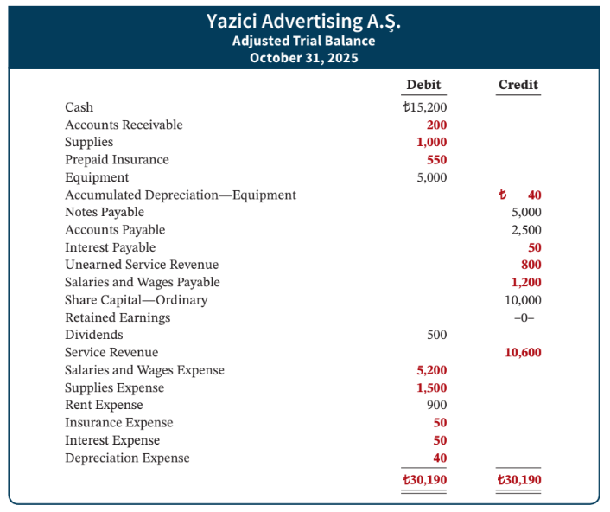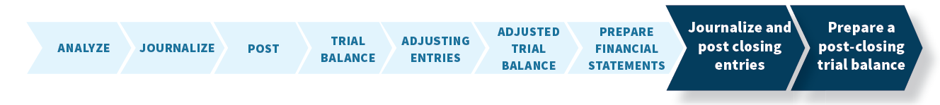An illustration of general journal format presents four closing entries in general journal format. This illustration presents a label at the top with the label, General Journal, centered. The next line presents five column headings of the journal as Date, Account Titles and Explanation, Reference, Debit and Credit. Immediately under the Date column label, 2025 is presented. The first journal entry of the date is presented as October 31. The debit part of the first transaction is recorded by presenting the account name, Service Revenue, adjacent to the date in the next column, with reference number, 400, and its amount of 10,600 in the debit column. The second part of the transaction is illustrated by presenting the credit account name, Income Summary, slightly indented on the next line, with reference number, 350, and its 10,600 amount in the credit column. Just below the Income Summary account name and slightly indented appears the description of the journal entry as: To close revenue account. The date of the second transaction is presented as October 31. The debit part of the transaction is recorded by presenting the account name, Income Summary, adjacent to the date in the next column, with reference number, 350, and its amount of 7,740 in the debit column. The second part of the transaction is illustrated by presenting the credit account name, Supplies Expense, slightly indented on the next line, with reference number, 631, and its 1,500 amount in the credit column. The third part of the transaction is illustrated by presenting the credit account name, Depreciation Expense, slightly indented on the next line, with reference number, 711, and its 40 amount in the credit column. The fourth part of the transaction is illustrated by presenting the credit account name, Insurance Expense, slightly indented on the next line, with reference number, 722, and its 50 amount in the credit column. The fifth part of the transaction is illustrated by presenting the credit account name, Salaries and Wages Expense, slightly indented on the next line, with reference number, 726, and its 5,200 amount in the credit column. The sixth part of the transaction is illustrated by presenting the credit account name, Rent Expense, slightly indented on the next line, with reference number, 729, and its 900 amount in the credit column. The seventh part of the transaction is illustrated by presenting the credit account name, Interest Expense, slightly indented on the next line, with reference number, 905, and its 50 amount in the credit column. Just below the Interest Expense account name and slightly indented appears the description of the journal entry as: To close expense accounts. The date of the third transaction is presented as October 31. The debit part of the transaction is recorded by presenting the account name, Income Summary (Turkish Lira 10,600 minus Turkish Lira 7,740), adjacent to the date in the next column, with reference number, 350, and its amount of 2,860 in the debit column. The second part of the transaction is illustrated by presenting the credit account name, Retained Earnings, slightly indented on the next line, with reference number, 320, and its 2,860 amount in the credit column. Just below the Retained Earnings account name and slightly indented appears the description of the journal entry as: To close net income to retained earnings. The date of the fourth transaction is presented as October 31. The debit part of the transaction is recorded by presenting the account name, Retained Earnings, adjacent to the date in the next column, with reference number, 320, and its amount of 500 in the debit column. The second part of the transaction is illustrated by presenting the credit account name, Dividends, slightly indented on the next line, with reference number, 332, and its 500 amount in the credit column. Just below the Dividends account name and slightly indented appears the description of the journal entry as: To close dividends to retained earnings.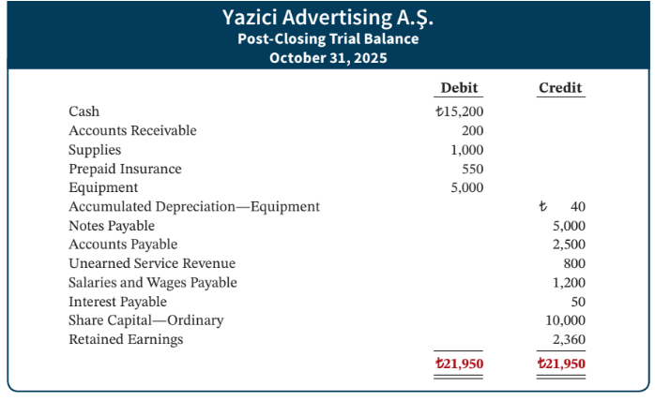An illustration presents general ledgers for permanent accounts only. Seven general ledgers are presented. General ledger 1: Illustration of the general journal format is presented. This illustration presents a label at the top with the label, Cash, centered. The next line presents six column headings of the journal as Date, Explanation, Reference, Debit, Credit, and Balance. Immediately under the Date column label, 2025 is presented. The first transaction dated, October 1, with reference number J 1, is recorded in an amount of 10,000 in the debit column and 10,000 in the balance column. The second transaction dated, October 2, with reference number J 1, is recorded in an amount of 1,200 in the debit column and 11,200 in the balance column. The third transaction dated, October 3, with reference number J 1, is recorded in an amount of 900 in the credit column and 10,300 in the balance column. The fourth transaction dated, October 4, with reference number J 1, is recorded in an amount of 600 in the credit column and 9,700 in the balance column. The fifth transaction dated, October 20, with reference number J 1, is recorded in an amount of 500 in the credit column and 9,200 in the balance column. The sixth transaction dated, October 26, with reference number J 1, is recorded in an amount of 4,000 in the credit column and 5,200 in the balance column. The seventh transaction dated, October 31, with reference number J 1, is recorded in an amount of 10,000 in the debit column and 15,200 (highlighted) in the balance column. ‘The journal page number '101' appears in the upper right corner.’ General ledger 2: Illustration of the general journal format is presented. This illustration presents a label at the top with the label, Accounts Receivable, centered. The next line presents six column headings of the journal as Date, Explanation, Reference, Debit, Credit, and Balance. Immediately under the Date column label, 2025 is presented. One transaction for adjusting entry dated, October 31, with reference number J 2, is recorded in an amount of 200 in the debit column and 200 (highlighted) in the balance column. ‘The journal page number '112' appears in the upper right corner.’ General ledger 3: Illustration of the general journal format is presented. This illustration presents a label at the top with the label, Supplies, centered. The next line presents six column headings of the journal as Date, Explanation, Reference, Debit, Credit, and Balance. Immediately under the Date column label, 2025 is presented. The first transaction dated, October 5, with reference number J 1, is recorded in an amount of 2,500 in the debit column and 2,500 in the balance column. The second transaction for adjusting entry dated, October 31, with reference number J 2, is recorded in an amount of 1,500 in the credit column and 1,000 in the balance column (highlighted). ‘The journal page number '126' appears in the upper right corner.’ General ledger 4: Illustration of the general journal format is presented. This illustration presents a label at the top with the label, Accounts Payable, centered. The next line presents six column headings of the journal as Date, Explanation, Reference, Debit, Credit, and Balance. Immediately under the Date column label, 2025 is presented. One transaction dated, October 5, with reference number J 1, is recorded in an amount of 2,500 in the credit column and 2,500 (highlighted) in the balance column. ‘The journal page number '201' appears in the upper right corner.’ General ledger 5: Illustration of the general journal format is presented. This illustration presents a label at the top with the label, Unearned Service Revenue, centered. The next line presents six column headings of the journal as Date, Explanation, Reference, Debit, Credit, and Balance. Immediately under the Date column label, 2025 is presented. The first transaction dated, October 2, with reference number J 1, is recorded in an amount of 1,200 in the credit column and 1,200 in the balance column. The second transaction for adjusting entry dated, October 31, with reference number J 2, is recorded in an amount of 400 in the debit column and 800 in the balance column (highlighted). ‘The journal page number '209' appears in the upper right corner.’ General ledger 6: Illustration of the general journal format is presented. This illustration presents a label at the top with the label, Salaries and Wages Payable, centered. The next line presents six column headings of the journal as Date, Explanation, Reference, Debit, Credit, and Balance. Immediately under the Date column label, 2025 is presented. One transaction for adjusting entry dated, October 31, with reference number J 2, is recorded in an amount of 1,200 in the credit column and 1,200 (highlighted) in the balance column. ‘The journal page number '212' appears in the upper right corner.’ General ledger 7: Illustration of the general journal format is presented. This illustration presents a label at the top with the label, Interest Payable, centered. The next line presents six column headings of the journal as Date, Explanation, Reference, Debit, Credit, and Balance. Immediately under the Date column label, 2025 is presented. One transaction for adjusting entry dated, October 31, with reference number J 2, is recorded in an amount of 50 in the credit column and 50 (highlighted) in the balance column. ‘The journal page number '230' appears in the upper right corner.’An illustration presents the general ledgers for temporary accounts only. Four general ledgers are presented. General ledger 1: Illustration of the general journal format is presented. This illustration presents a label at the top with the label, Dividends, centered. The next line presents six column headings of the journal as Date, Explanation, Reference, Debit, Credit, and Balance. Immediately under the Date column label, 2025 is presented. The first transaction dated, October 20, with reference number J 1, is recorded in an amount of 500 in the debit column and 500 in the balance column. The second transaction for closing entry dated, October 31, with reference number J 3, is recorded in an amount of 500 in the credit column and 0 in the balance column (this row is highlighted). ‘The journal page number '332' appears in the upper right corner. 'General ledger 2: Illustration of the general journal format is presented. This illustration presents a label at the top with the label, Income Summary, centered. The next line presents six column headings of the journal as Date, Explanation, Reference, Debit, Credit, and Balance. Immediately under the Date column label, 2025 is presented. The first transaction for closing entry dated, October 31, with reference number J 3, is recorded in an amount of 10,600 in the credit column and 10,600 in the balance column. The second transaction for closing entry dated, October 31, with reference number J 3, is recorded in an amount of 7,740 in the debit column and 2,860 in the balance column (this row is highlighted). The third transaction for closing entry dated, October 31, with reference number J 3, is recorded in an amount of 2,860 in the debit column and 0 in the balance column (this row is highlighted). ‘The journal page number '350' appears in the upper right corner. 'General ledger 3: Illustration of the general journal format is presented. This illustration presents a label at the top with the label, Insurance Expense, centered. The next line presents six column headings of the journal as Date, Explanation, Reference, Debit, Credit, and Balance. Immediately under the Date column label, 2025 is presented. The first transaction for adjusting entry dated, October 31, with reference number J 2, is recorded in an amount of 50 in the debit column and 50 in the balance column. The second transaction for closing entry dated, October 31, with reference number J 3, is recorded in an amount of 50 in the credit column and 0 in the balance column (this row is highlighted). ‘The journal page number '722' appears in the upper right corner. 'General ledger 4: Illustration of the general journal format is presented. This illustration presents a label at the top with the label, Salaries and Wages Expense, centered. The next line presents six column headings of the journal as Date, Explanation, Reference, Debit, Credit, and Balance. Immediately under the Date column label, 2025 is presented. The first transaction dated, October 26, with reference number J 1, is recorded in an amount of 4,000 in the debit column and 4,000 in the balance column. The second transaction for adjusting entry dated, October 31, with reference number J 2, is recorded in an amount of 1,200 in the debit column and 5,200 in the balance column. The third transaction for closing entry dated, October 31, with reference number J 3, is recorded in an amount of 5,200 in the credit column and 0 in the balance column (this row is highlighted). ‘The journal page number '726' appears in the upper right corner.’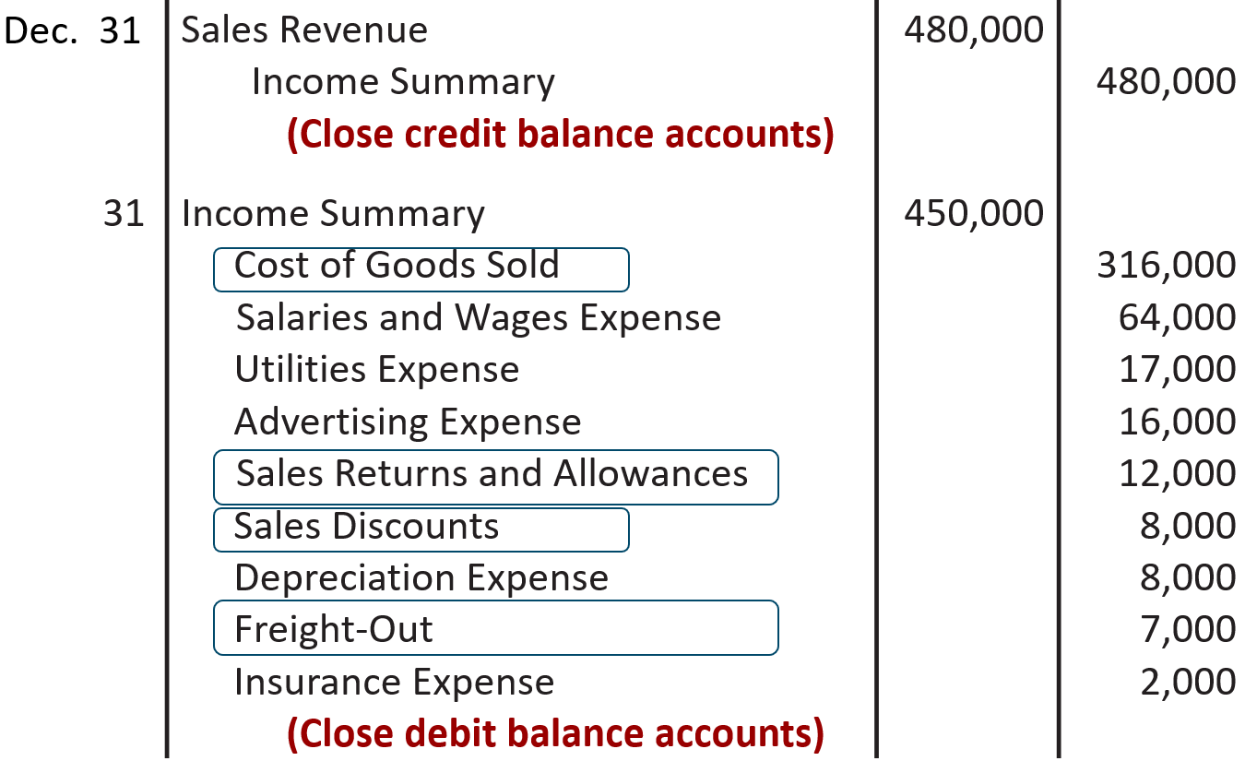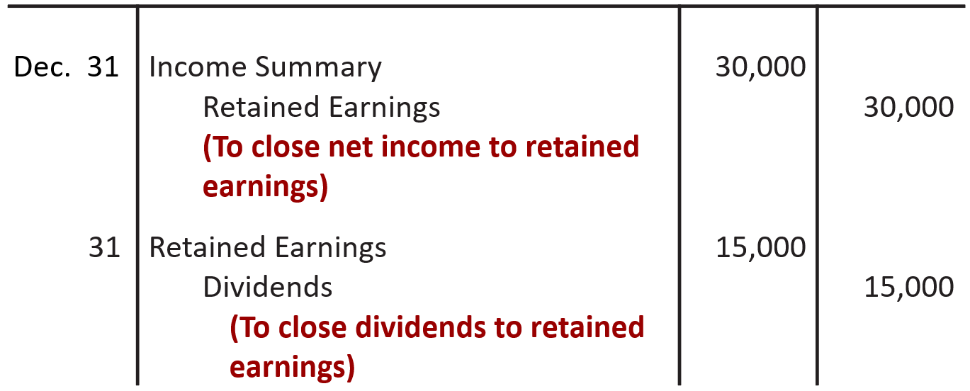

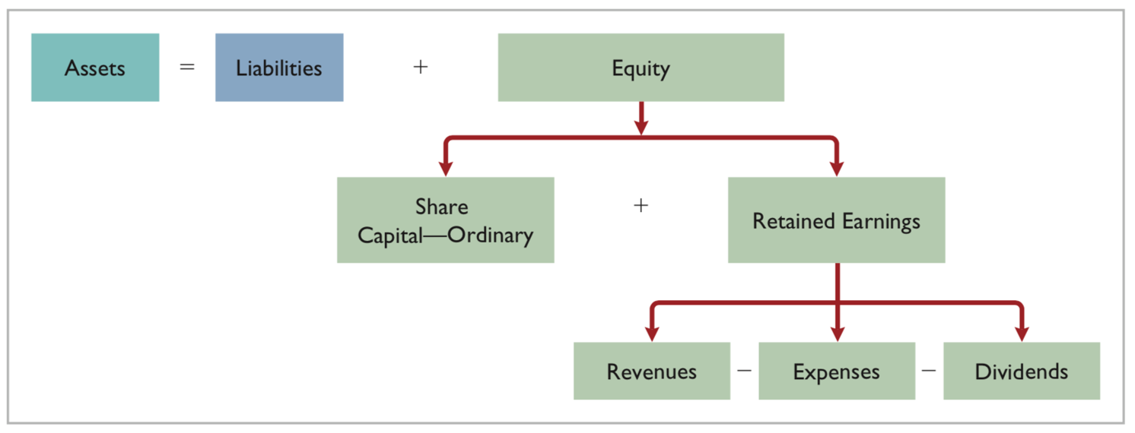

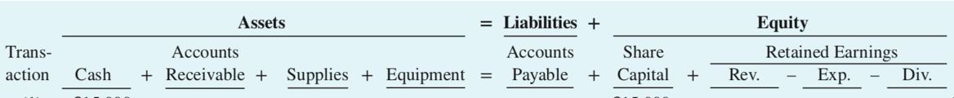

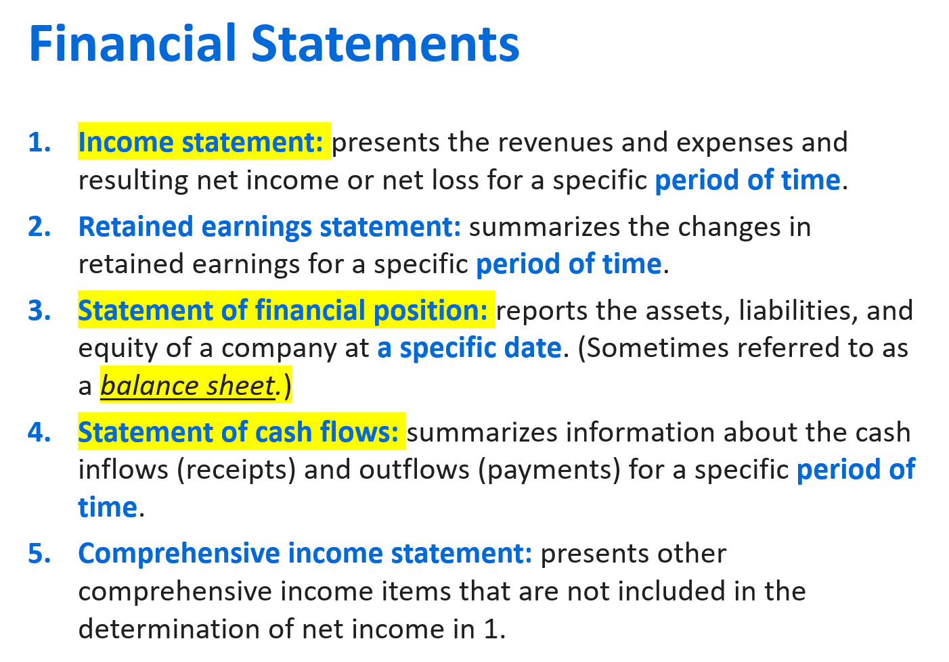

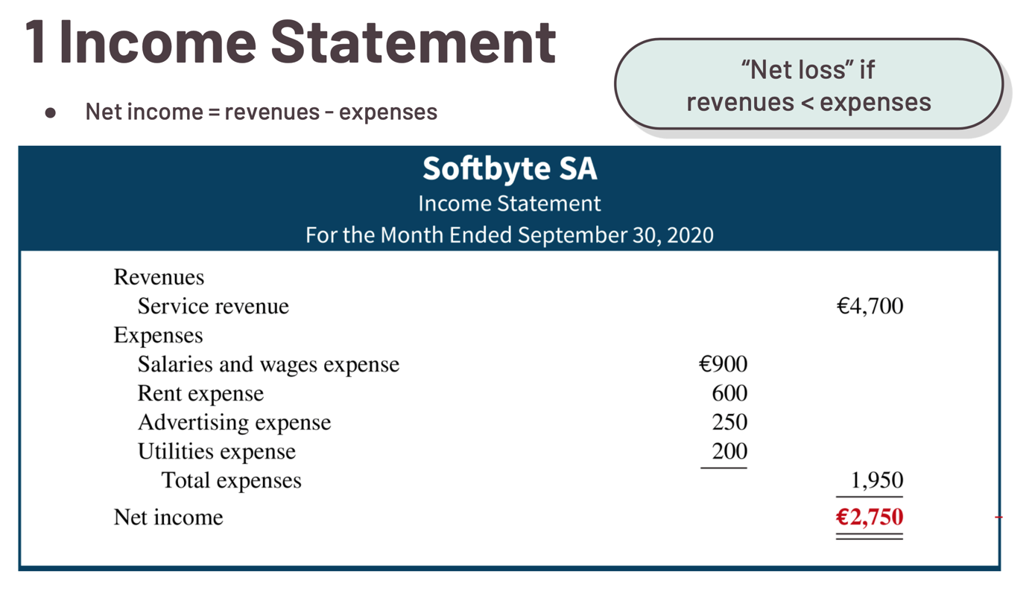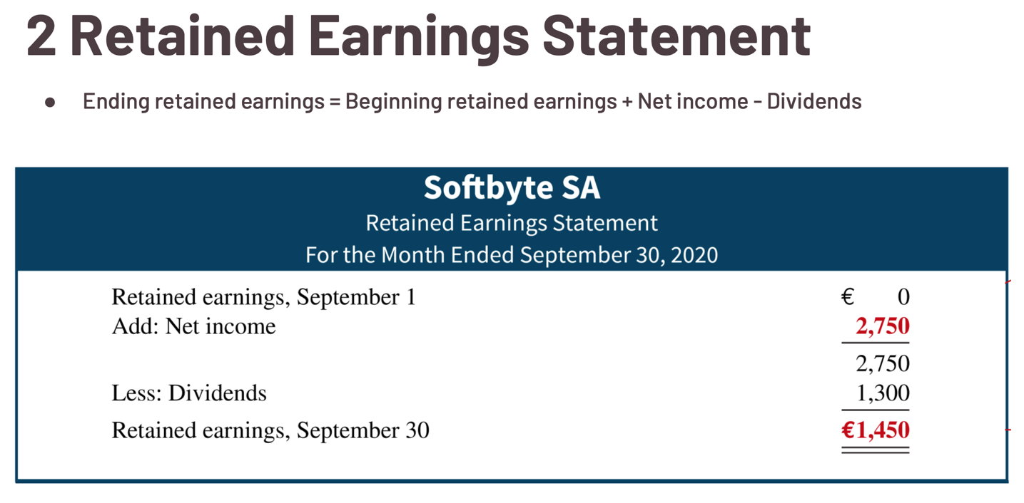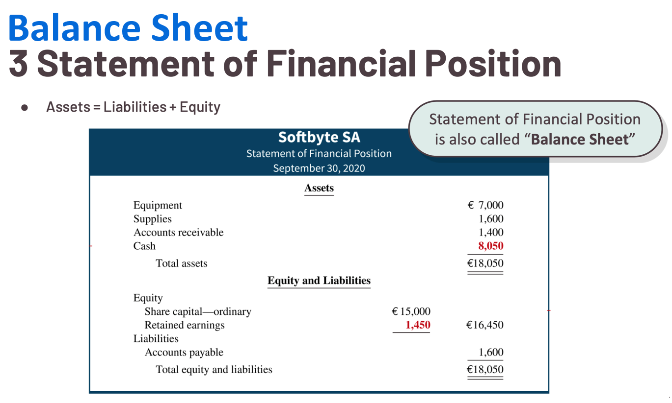An illustration of an adjusted trial balance is presented along with the statement of financial position. The adjusted trial balance begins with a three-line heading consisting of the name of the company, Yazici Advertising A.S; type of statement, Adjusted Trial Balance; and the date for which the statement is prepared, October 31, 2025. The following accounts are listed in the first column of the adjusted trial balance along with the balances either in the debit or credit columns: Cash: Turkish Lira 15,200, debit; Accounts Receivable: 200, debit; Supplies: 1,000, debit; Prepaid Insurance: 550, debit; Equipment: 5,000, debit; Accumulated Depreciation Equipment: Turkish Lira 40, credit; Notes Payable: 5,000, credit; Accounts Payable: 2,500, credit; Unearned Service Revenue: 800, credit; Salaries and Wages Payable: 1,200, credit; Interest Payable: 50, credit; Share Capital—Ordinary: 10,000, credit; Retained Earnings: 0, debit; Dividends: 500, debit; Service Revenue: 10,600, credit; Salaries and Wages Expense: 5,200, debit; Supplies Expense: 1,500, debit; Rent Expense: 900, debit; Insurance Expense: 50, debit; Interest Expense: 50, debit; and Depreciation Expense: 40, debit. Total debits and total credits of Turkish Lira 30,190 are equal on both the debit and credit sides. The statement of financial position begins with a three-line heading consisting of the name of the company, Yazici Advertising A.S; type of statement, Statement of Financial Position; and the date on which the statement is prepared, October 31, 2025. There are arrows pointing from the respective account balances on the trial balance to the amounts on the balance sheet to illustrate the preparation of the balance sheet. The assets section of the balance sheet presents the names of all of the asset accounts in the first column and their respective balances in the two numeric columns as: Equipment: Turkish Lira 5,000; Less Accumulated depreciation equipment: 40, for a net amount listed as 4,960 in the second numeric column; Prepaid insurance: 550; Supplies: 1,000; Accounts receivable: 200; Cash: 15,200. The assets are totaled and presented as total assets of Turkish Lira 21,910 in the second numeric column. The equity and liabilities section of the statement of financial position contains all the equity in the first column and their respective amounts from the adjusted trial balance in the two numeric columns as: as follows: Share capital—ordinary, Turkish Lira, 10,000; Retained earnings, 2,360. The equity are totaled and presented as total equity in the amount of Turkish Lira 12,360 in the second numeric column. The liabilities section of the statement of financial position contains all the liabilities in the first column and their respective balances from the adjusted trial balance in the two numeric columns as follows: Notes payable, 5,000; Accounts payable, 2,500; Unearned service revenue, 800; Salaries and wages payable, 1,200; Interest payable, 50. The liabilities are totaled and presented in the amount of Turkish Lira 9,550 in the second numeric column. The label of: Total equity and liabilities, is presented in the first column, with the total of Turkish Lira 21,910 displayed in the second numeric column and the final total. The retained earnings amount of Turkish Lira 12,360 is the balance at October 31 from the retained earnings statement in illustration 3.27.

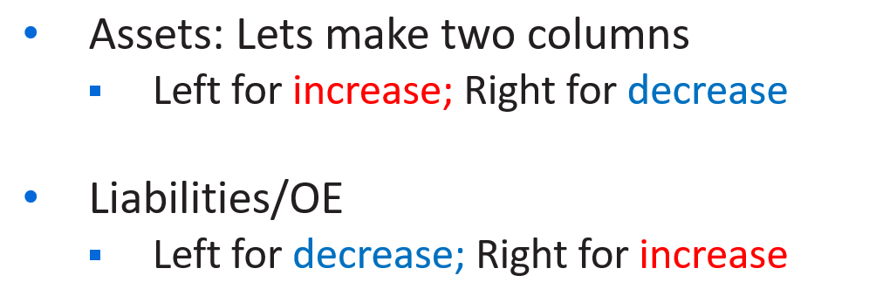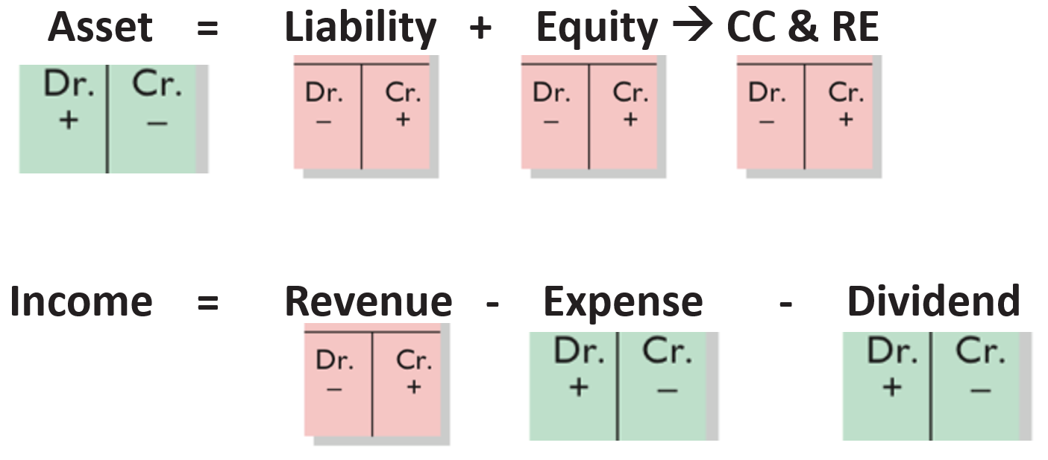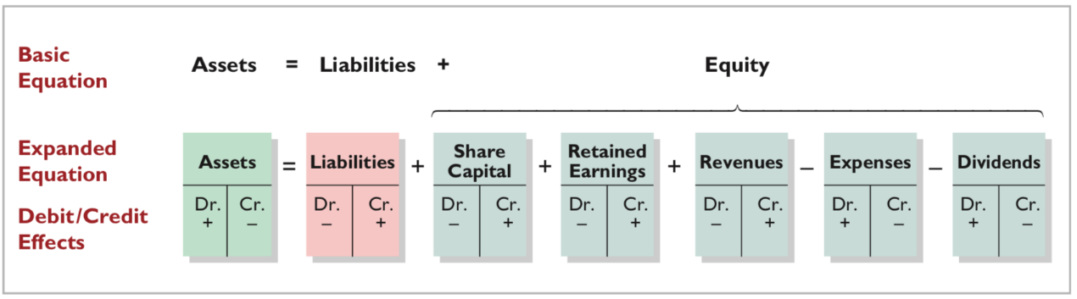

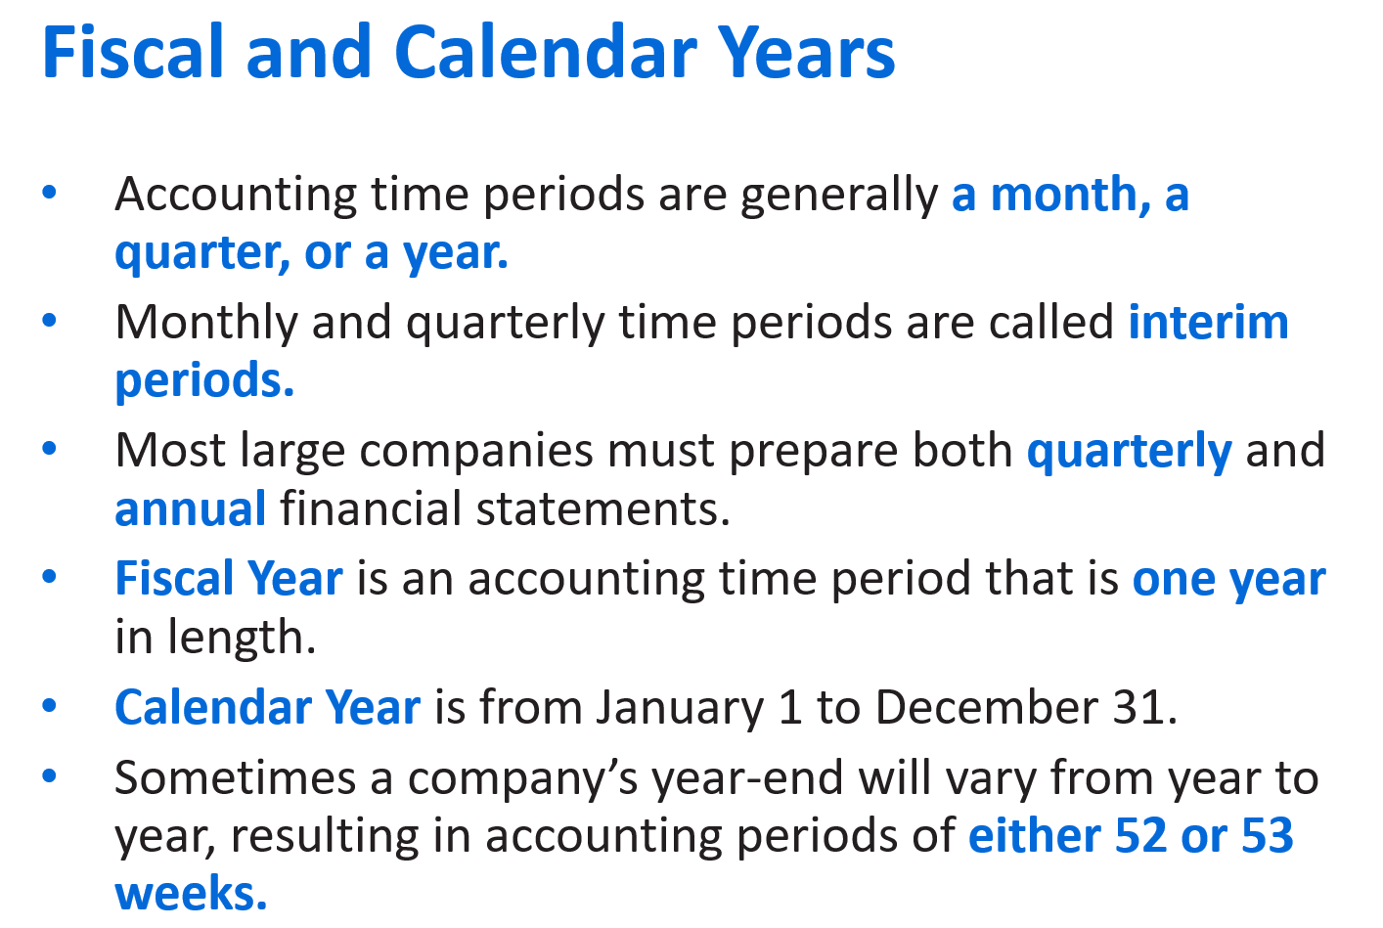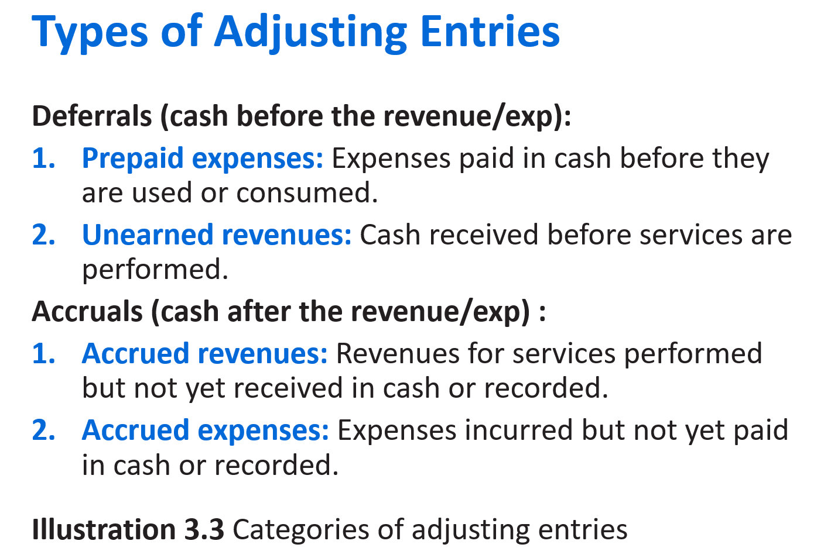

**Prepaid Expenses:** Insurance, supplies, advertising, rent, depreciation 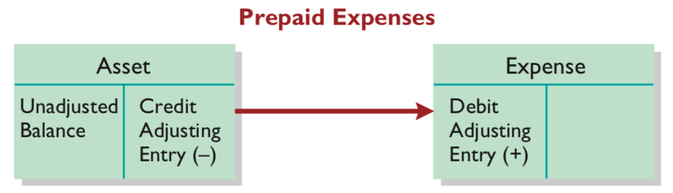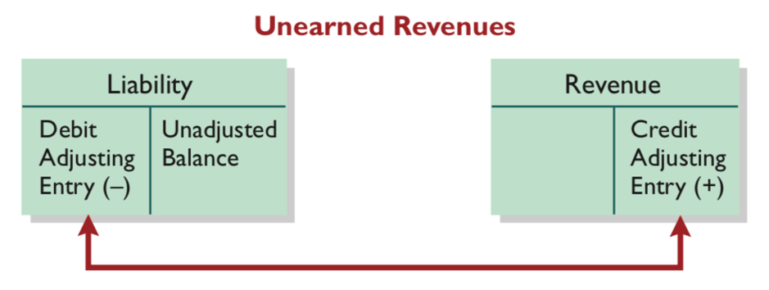

**Unearned Revenues:** Rent (landlord rent out an apartment), magazine subscriptions, customer deposits for future service

**Accrued Revenue:** Interest (bank), rent (pay rent after the month passed), services

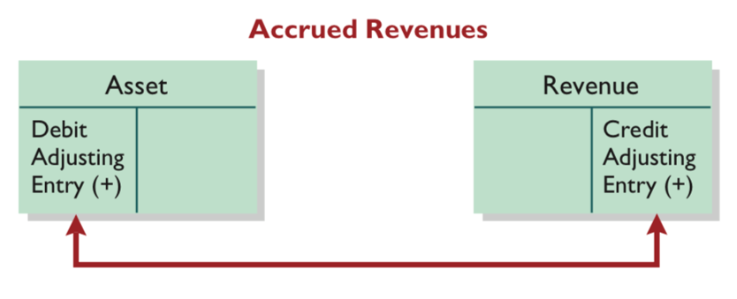 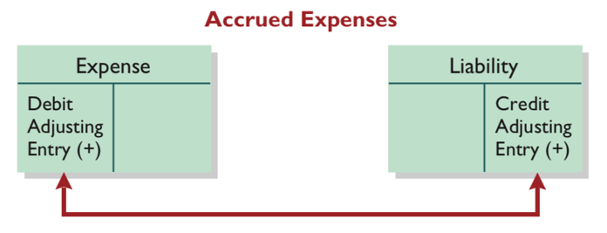

**Accrued Expenses:** Interest, salaries

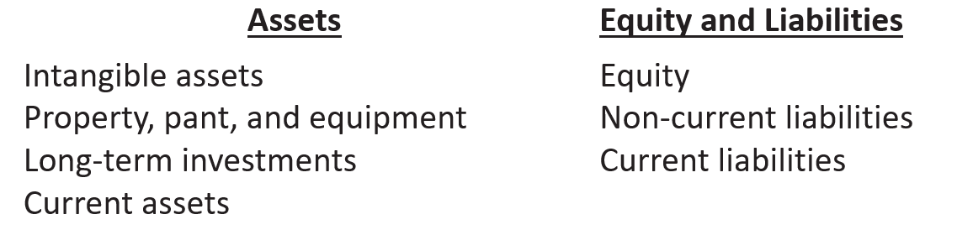An illustration of a classified statement of financial position. The statement presents a four-line heading consisting of the name of the company, Cheng Limited; the type of statement, Statement of Financial Position; the date at which the statement is prepared, October 31, 2025; and the values in which the statement is prepared, (New Taiwan $ in thousands). This illustration presents the Assets section of the balance sheet, with the label, Assets, centered and shown in bold type, with 4 subsections listed below. There are 4 columns presented, the first presenting account names and the other three presenting the respective amounts and totals. The first asset subsection is labeled as Intangible assets in the first column. Immediately below slightly indented, Patents, is listed, with its respective amount of New Taiwan $3,100 presented in the last numeric column. The second asset subsection is labeled as: Property, plant, and equipment, in the first column. Immediately below with a slight indention appears a list of three accounts with their respective amounts: Land, listed in the second numeric column as New Taiwan $10,000; Equipment, listed as New Taiwan $24,000 in the first numeric column; and Less: Accumulated depreciation, listed as 5,000 in the first numeric column. The accumulated depreciation amount is subtracted from the 24,000 equipment cost, and the difference presented in the second numeric column as 19,000. The cost of the land of 10,000 is added to the net equipment amount of 19,000, and the total is presented in the second of the third numeric column as 29,000. The third asset subsection is labeled as Long-term investments. The following account names are indented slightly in this section, and the respective amounts appear in the second of two numeric columns: Stock investments, 5,200; and Investment in real estate, 2,000. The amounts are totaled as 7,200 which appears in the third numeric column adjacent to the 2,000 amount. The fourth subsection, Current assets, is presented in the first column. The following account names are listed in this section slightly indented with the respective amounts listed in the second of the three numeric columns: Prepaid insurance, 400; Supplies, 2,100; Inventory, 3,000; Notes receivable, 1,000; Accounts receivable, 7,000; Short-term investments, 2,000; and Cash, 6,600. The amounts are totaled as 22,100 which appears in the third numeric column adjacent to the 6,600 amount. Finally, the total of all four subsections is presented in the last numeric column as New Taiwan $61,400 with the label, Total assets, listed in the first column.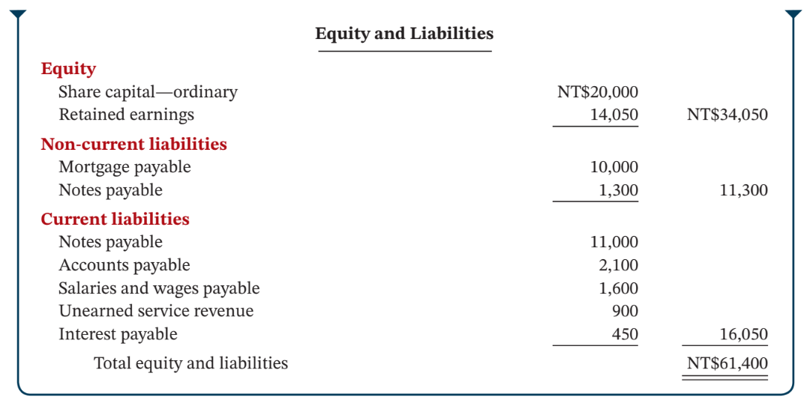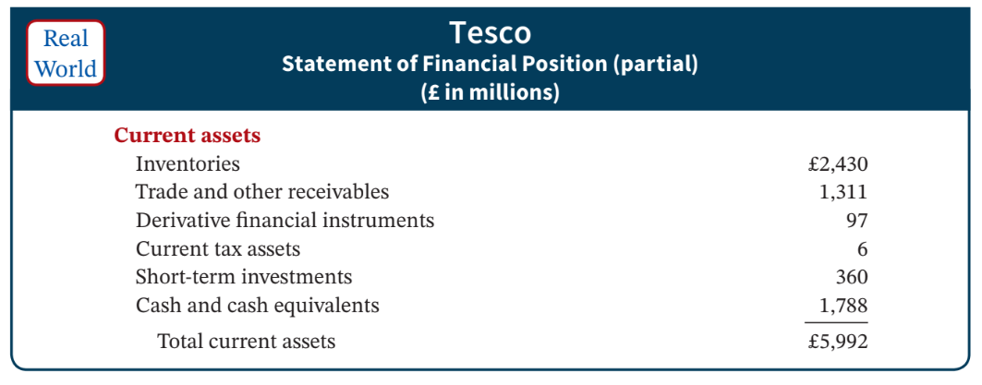

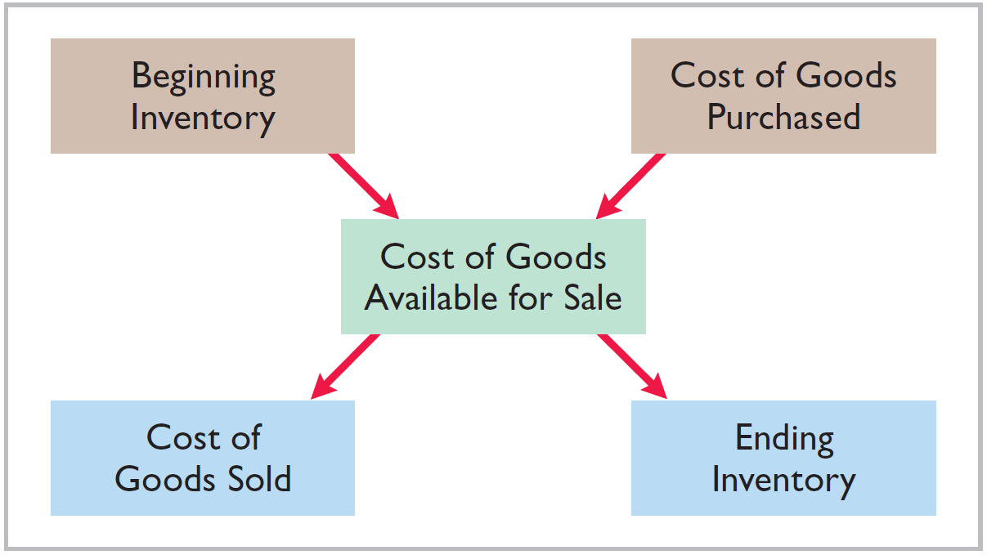

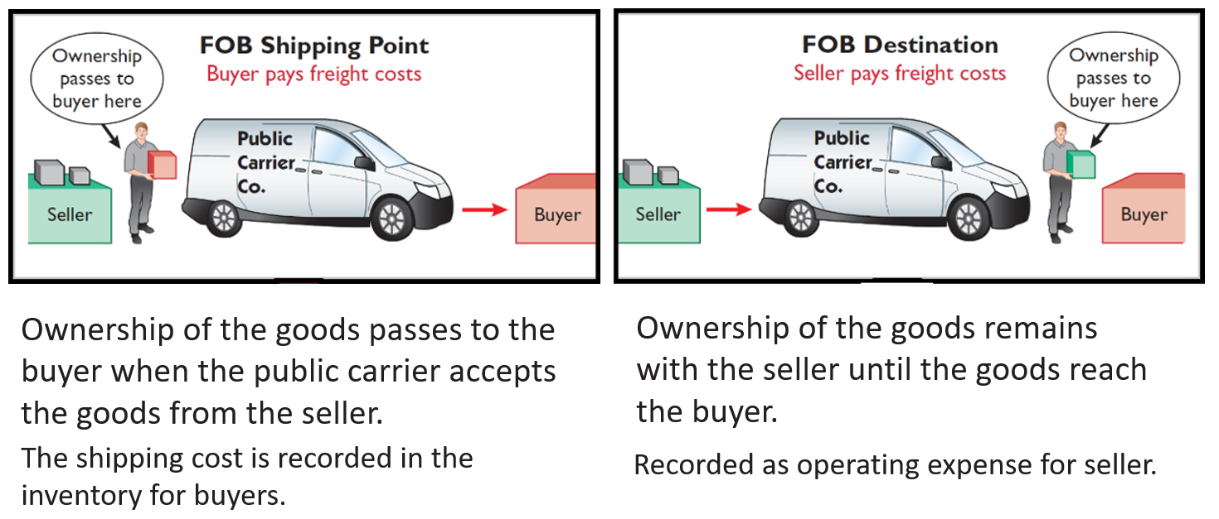

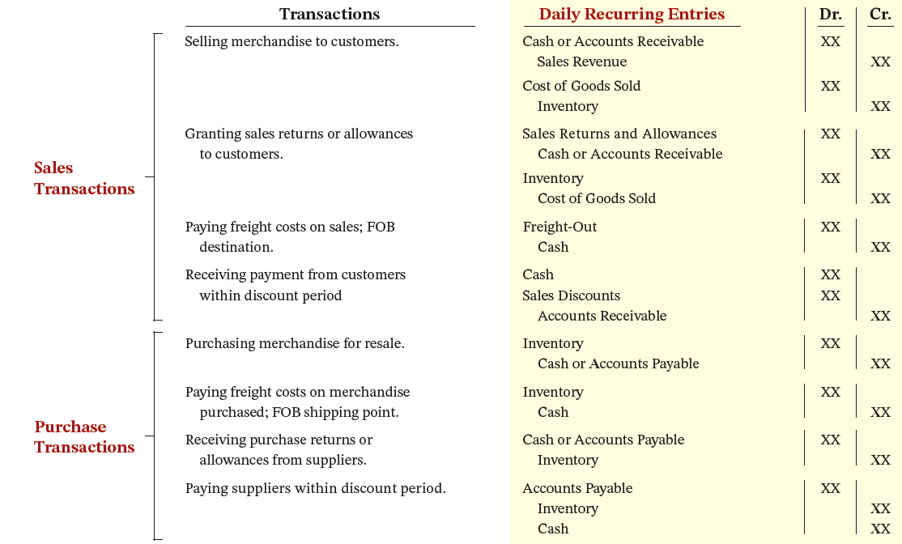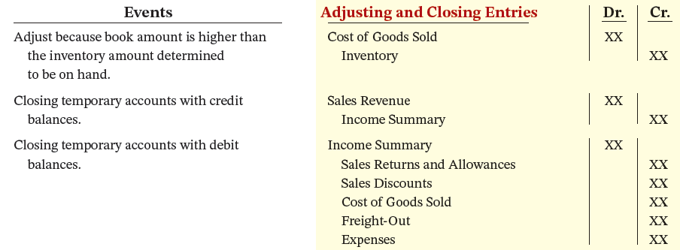

An illustration of an Income Statement is presented that contains a three-line heading consisting of the name of the company, P W Audio Supply; the type of statement, Income Statement; and the time period the statement covers, For the Year ended December 31, 2025. The statement consists of three columns with the first column displaying the account names and the other two presenting the respective amounts. The statement contains three sections. The Sales section is presented first with the calculation of gross profit, beginning with Sales. Sales revenue is next with Euro 480,000 presented in the third column. Less: Sales returns and allowances, and Sales discounts, are presented on the next two lines, with Euro 12,000 and 8,000 amounts, respectively, in the second column. The total of these two accounts is 20,000 and is presented in the last column followed by net Sales at 460,000 also listed in the last column. Cost of goods sold is next, and is presented as 316,000, followed by gross profit at 144,000. The operating expense section is next. Just below gross profit is the operating expenses section with the following account names and amounts listed in the first column: Salaries and wages expense, 64,000, Utilities expense, 17,000, Advertising expense, 16,000, Depreciation expense, 8,000, Freight-out, 7,000, and Insurance expense, 2,000. Total operating expenses is the sum of the above and is presented as 114,000 in the second numeric column. Income from operations, which is gross profit minus total operating expense, equals 30,000, presented in the second numeric column. The third section is Other income and expenses comprising of Interest revenue, 3,000, Gain on sale of equipment, 600, and Casualty loss from vandalism, negative 200 (shown in parentheses). The sum is presented in the second numeric column as 3,400. The Other expenses and losses section show Interest expense, 1,800 presented in the second numeric column. The next line presents Net income in the first column, with an amount of Euro 31,600 in the second numeric column.



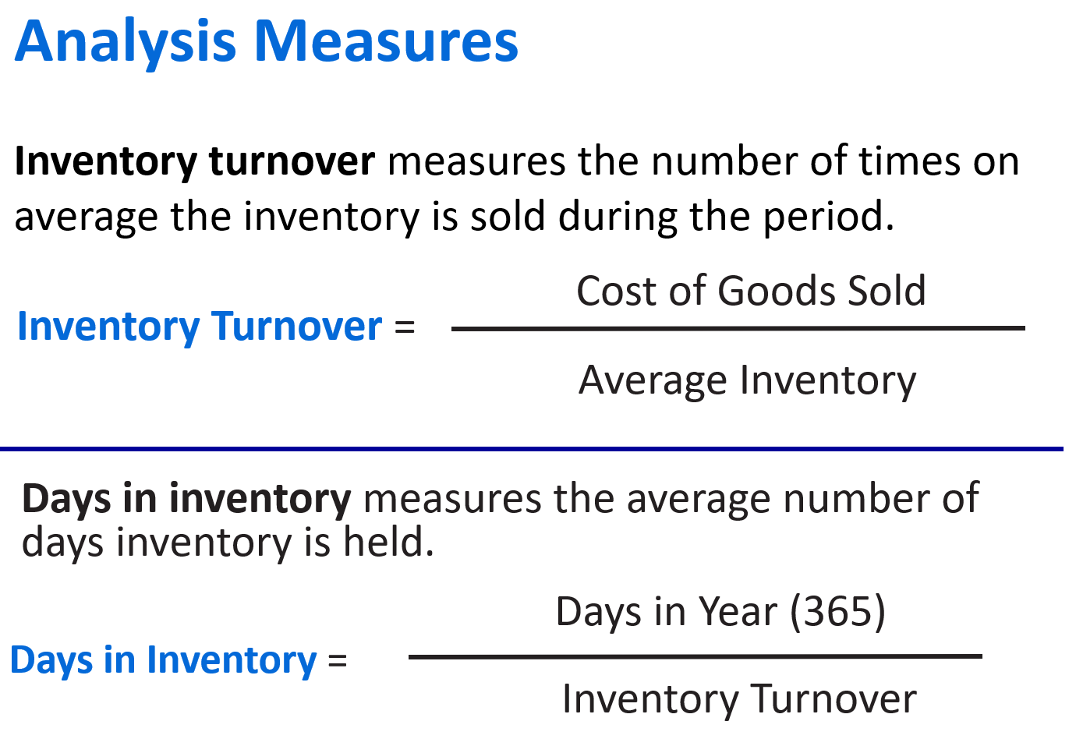

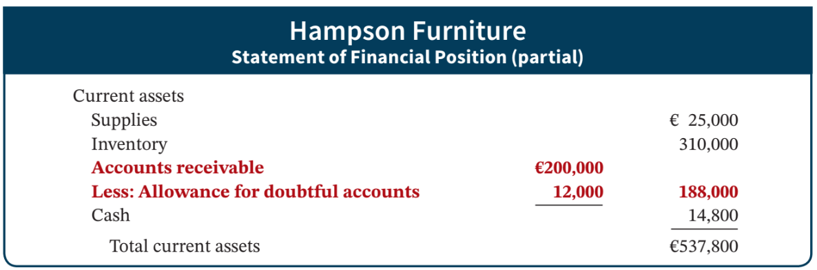

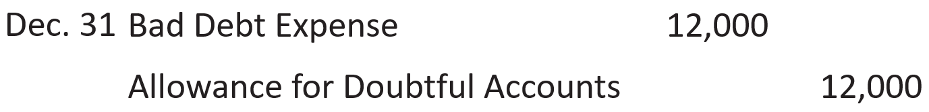

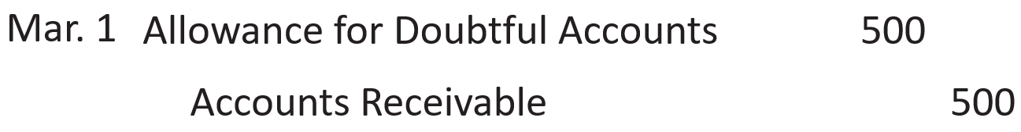

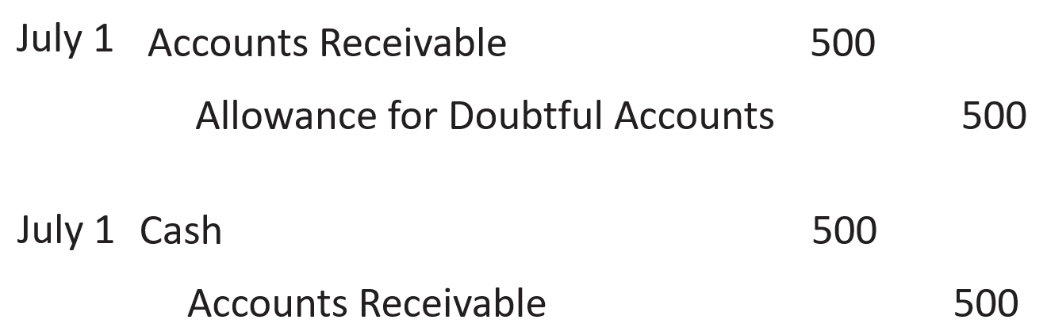

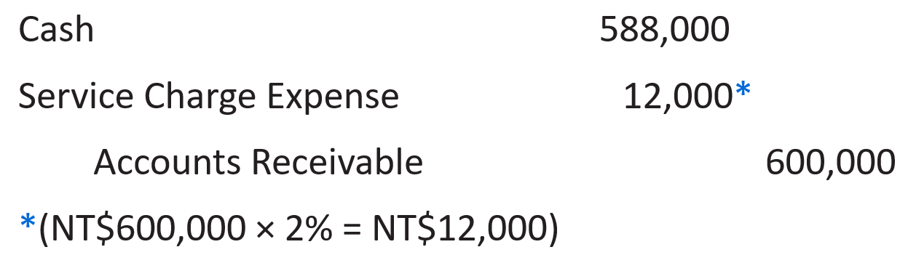

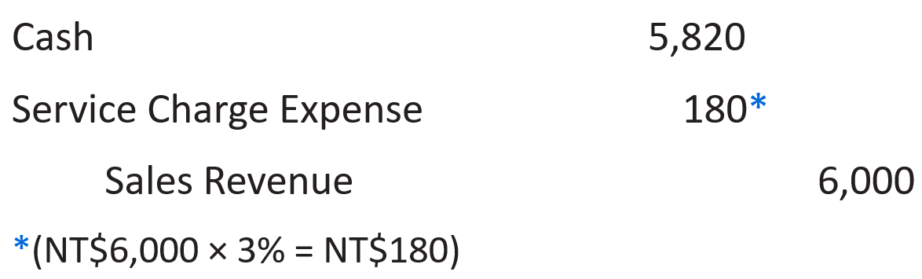

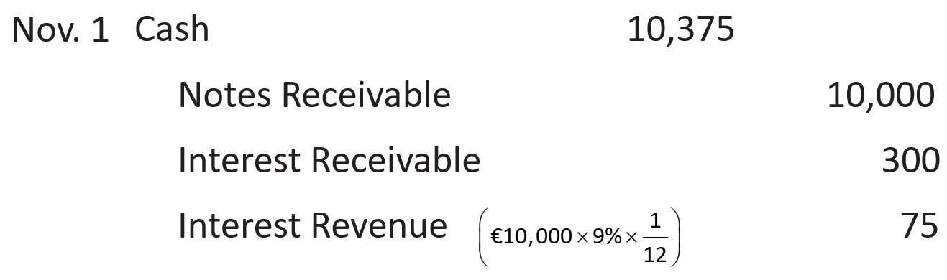

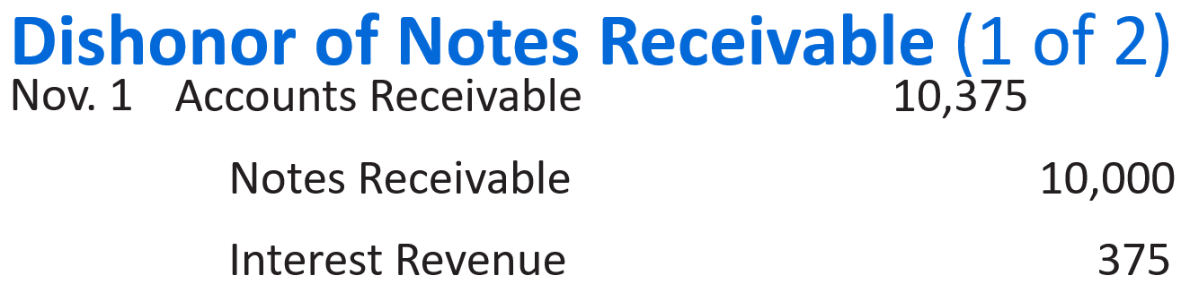

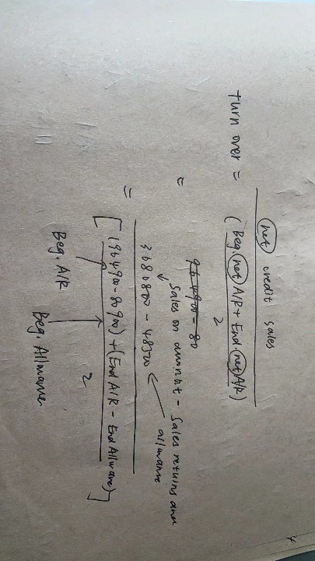

FIFO method produces the higher ending inventory.

Average-cost method produces the higher cost of goods sold.